 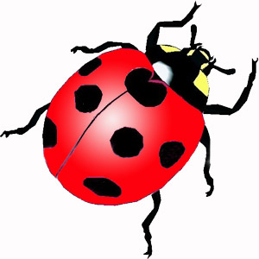 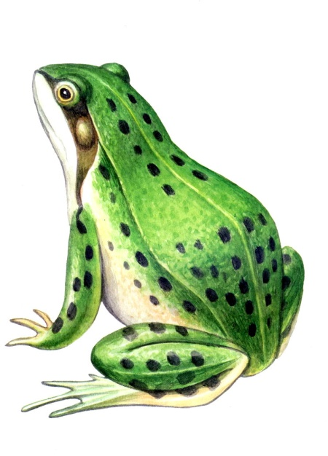

1.  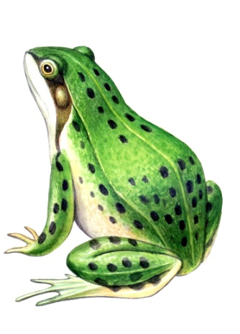 ­­­­­­­­­­­­________ ________
2.  ________ ________
3. 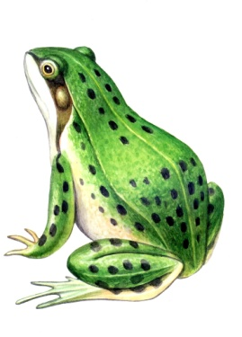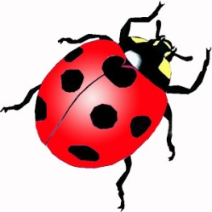_____ _____ _____
4. _____ _____ _____