Karta 1

[](https://www.google.de/url?sa=i&url=http%3A%2F%2Fpp65.eprzedszkola.pl%2F%3Fm%3Dstrona%26id%3D24&psig=AOvVaw1aoqrFzD2_SnA0XTbn2Ic8&ust=1591598096088000&source=images&cd=vfe&ved=0CAIQjRxqFwoTCLiT2aeL7-kCFQAAAAAdAAAAABAD) [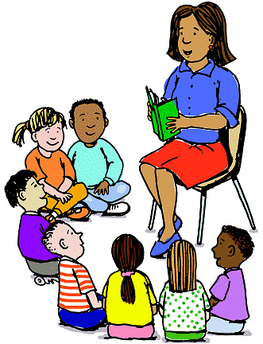](https://www.google.de/url?sa=i&url=https%3A%2F%2Fpp11.pila.pl%2FO-nas%2Fpersonel&psig=AOvVaw0D6JBVm4cJ_Rv51l80_exy&ust=1591597877735000&source=images&cd=vfe&ved=0CAIQjRxqFwoTCIj-27uK7-kCFQAAAAAdAAAAABAE)

[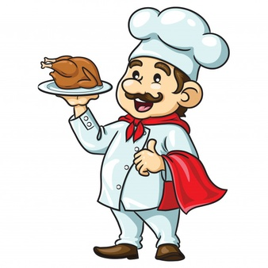](https://www.google.de/url?sa=i&url=https%3A%2F%2Fpl.freepik.com%2Fdarmowe-zdjecie-wektory%2Fkreskowka-kucharz&psig=AOvVaw13-G_Vwki3NlMOKo0bQgYl&ust=1591598304907000&source=images&cd=vfe&ved=0CAIQjRxqFwoTCLjzkIiM7-kCFQAAAAAdAAAAABAX) [](https://www.google.de/url?sa=i&url=https%3A%2F%2Fwww.facebook.com%2Fzlota.raczka24h%2F&psig=AOvVaw2J2vVtu7oAv7k5bbILhKTC&ust=1591599568657000&source=images&cd=vfe&ved=0CAIQjRxqFwoTCNCysMuQ7-kCFQAAAAAdAAAAABAD)