Karta 3

[](https://www.google.de/url?sa=i&url=https%3A%2F%2Fpl.pinterest.com%2Fpin%2F711498441103477571%2F&psig=AOvVaw2jd71cTnVfcRq5TNFL5SUm&ust=1591269300261000&source=images&cd=vfe&ved=0CAIQjRxqFwoTCODCgsHC5ekCFQAAAAAdAAAAABAD) [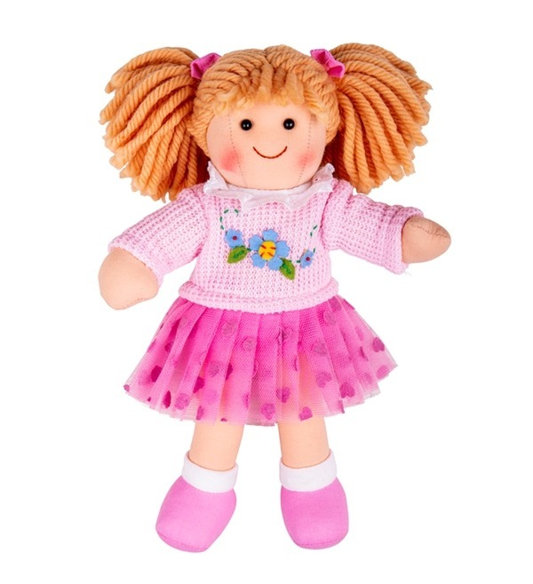](https://www.google.de/url?sa=i&url=https%3A%2F%2Fwww.zielonezabawki.pl%2Fproduct-zun-25704-Lalka-dla-dzieci-Lara-BJD049-Bigjigs-Toys-zabawki-dla-dziewczynek.html&psig=AOvVaw1sXjU5PnbYV-yYOs4svztJ&ust=1591270079050000&source=images&cd=vfe&ved=0CAIQjRxqFwoTCODa4JbF5ekCFQAAAAAdAAAAABAD)