Karta 1

[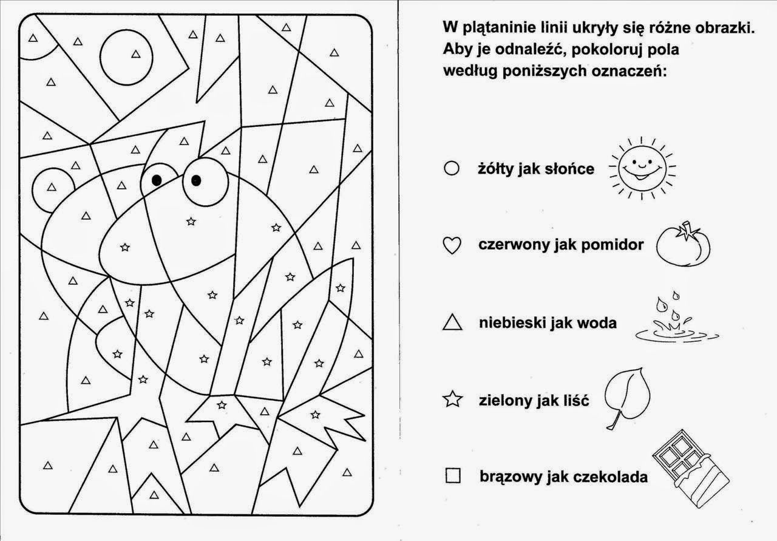](https://www.google.de/url?sa=i&url=https%3A%2F%2Fwww.pinterest.cl%2Fpin%2F227783693640096497%2F&psig=AOvVaw2YnA3TeWydGqoSS8uaud1v&ust=1589549258078000&source=images&cd=vfe&ved=0CAIQjRxqFwoTCKjpyOq6s-kCFQAAAAAdAAAAABAJ)