Karta nr 1

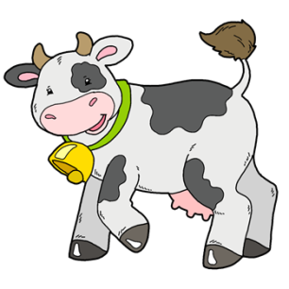

[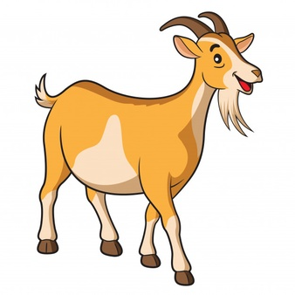](https://www.google.de/url?sa=i&url=https%3A%2F%2Fpl.freepik.com%2Fdarmowe-zdjecie-wektory%2Fkoza&psig=AOvVaw27KZ42PK40TsKAhnpsiJbV&ust=1587384225759000&source=images&cd=vfe&ved=0CAIQjRxqFwoTCICEx5u59OgCFQAAAAAdAAAAABAD)

[](https://www.google.de/url?sa=i&url=https%3A%2F%2Fpl.freepik.com%2Fdarmowe-wektory%2Fsliczna-swinia-z-rozowa-skora-na-bielu_6952407.htm&psig=AOvVaw0FLL46BjxadDQ0_wBf0eVh&ust=1587384323247000&source=images&cd=vfe&ved=0CAIQjRxqFwoTCICUiMq59OgCFQAAAAAdAAAAABAD)