[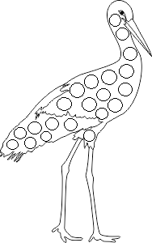](https://www.google.de/url?sa=i&url=https%3A%2F%2Fwww.pinterest.com%2Fpin%2F522276888030908805%2F&psig=AOvVaw2guAOLurfaaIXW0_d8EDH3&ust=1585118862927000&source=images&cd=vfe&ved=0CAIQjRxqFwoTCJjIvqHCsugCFQAAAAAdAAAAABAy)